**Hspice Homework3**

As the amplifier circuits shown in the following Figs. (a), (b), and (c), please perform HSPICE simulations with the device parameters of U18 0.18µm CMOS technology. Simulate at TT corner with temperature 25°.

From your simulation results,

1. Find the low-frequency voltage gain Av=Vout/Vin and the 3-dB bandwidth by using AC analysis for the amplifiers in Figs. (a), (b), and (c), respectively.

**Figure a:**

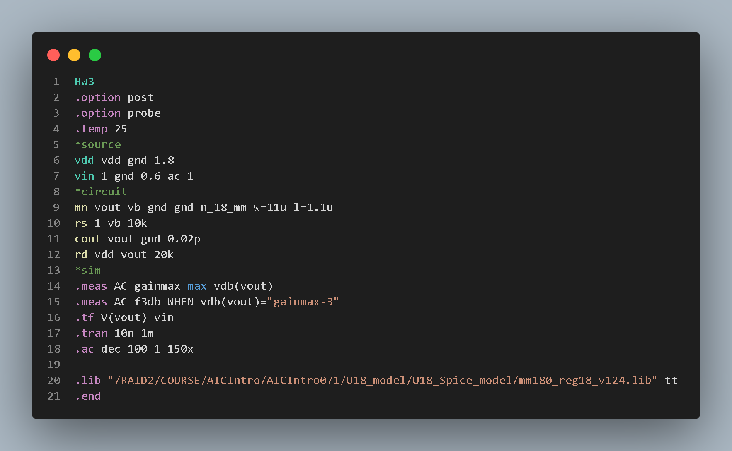



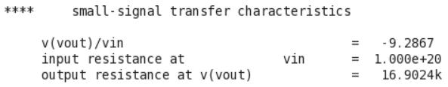

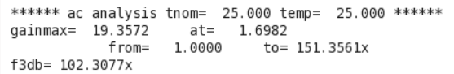

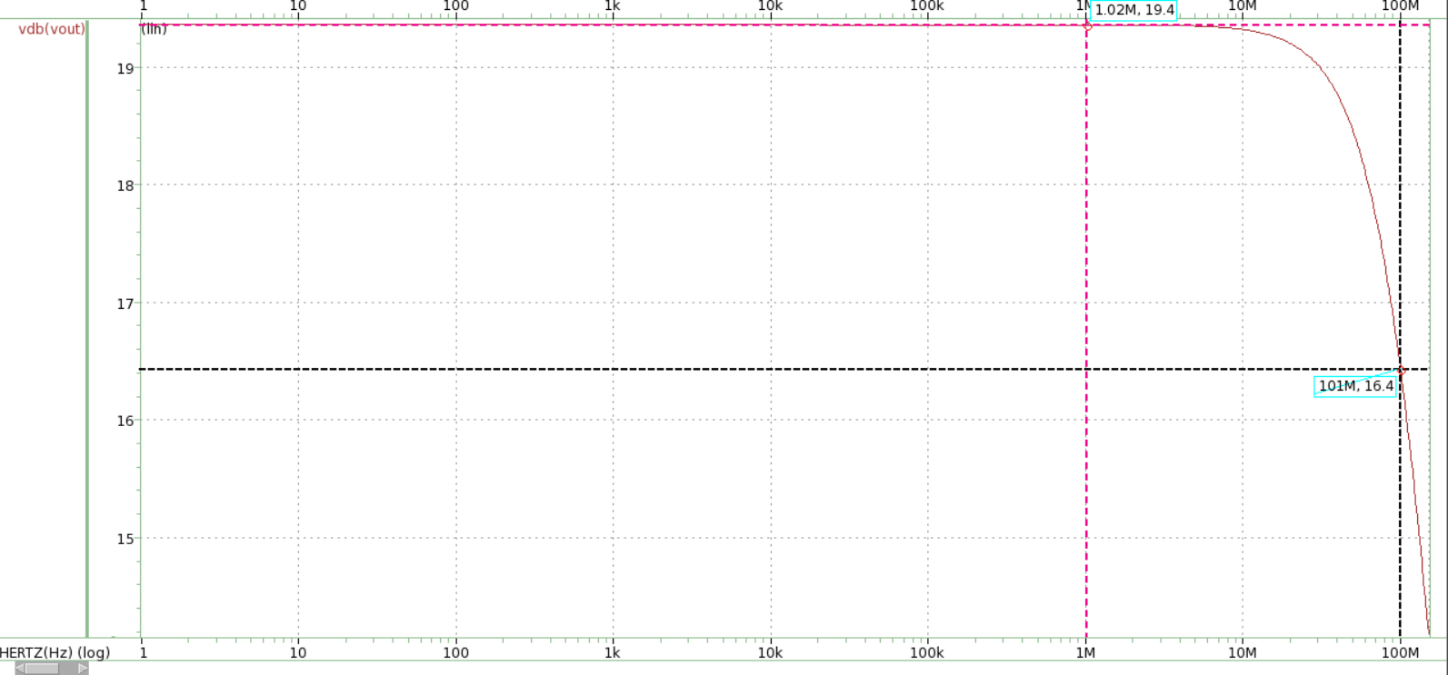

Gain=-9.2867

f-3db=101MHz

**Figure b:**

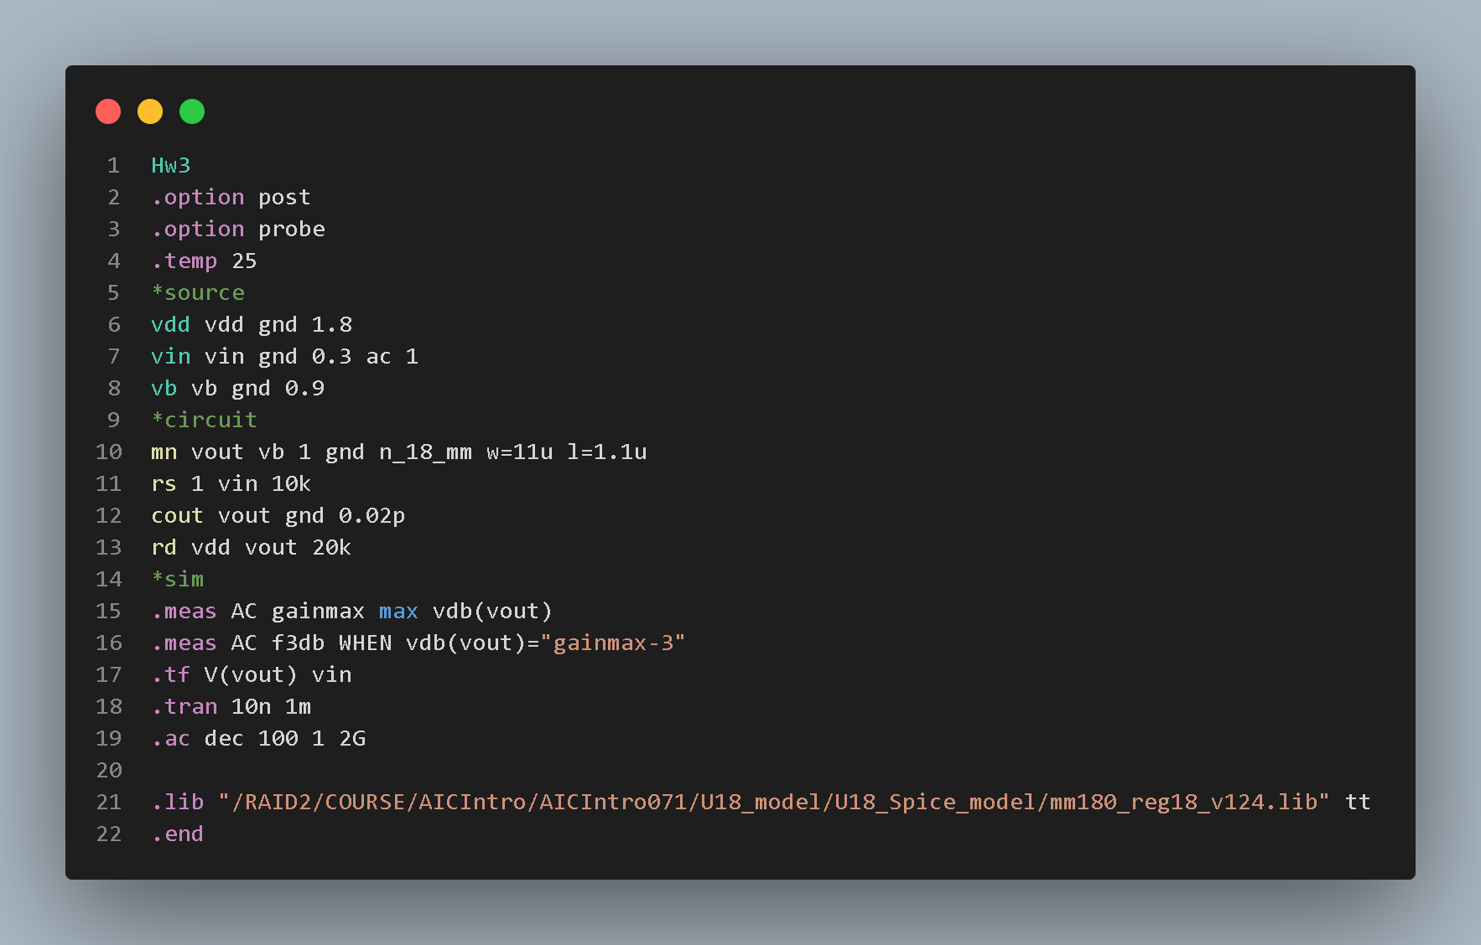



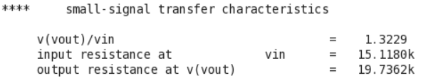

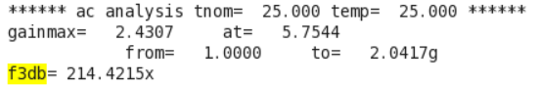

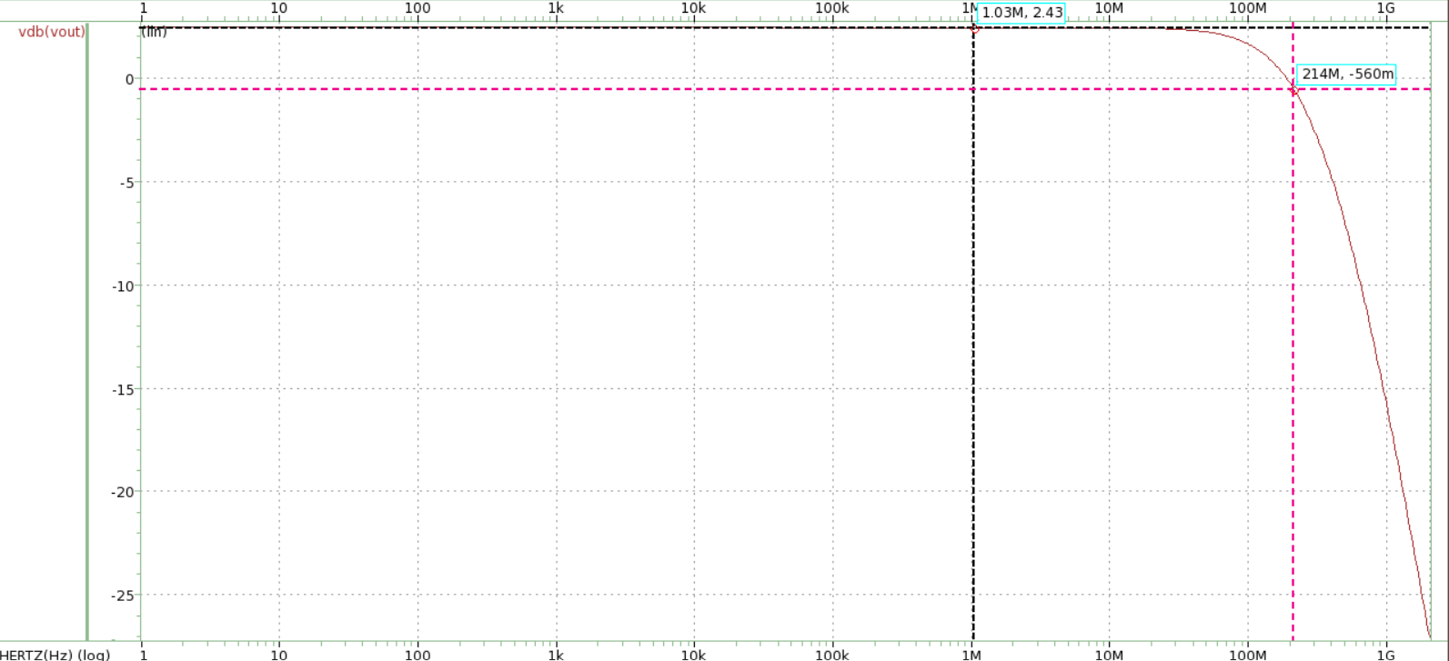

Gain=1.3229

f-3db=214MHz

**Figure c:**

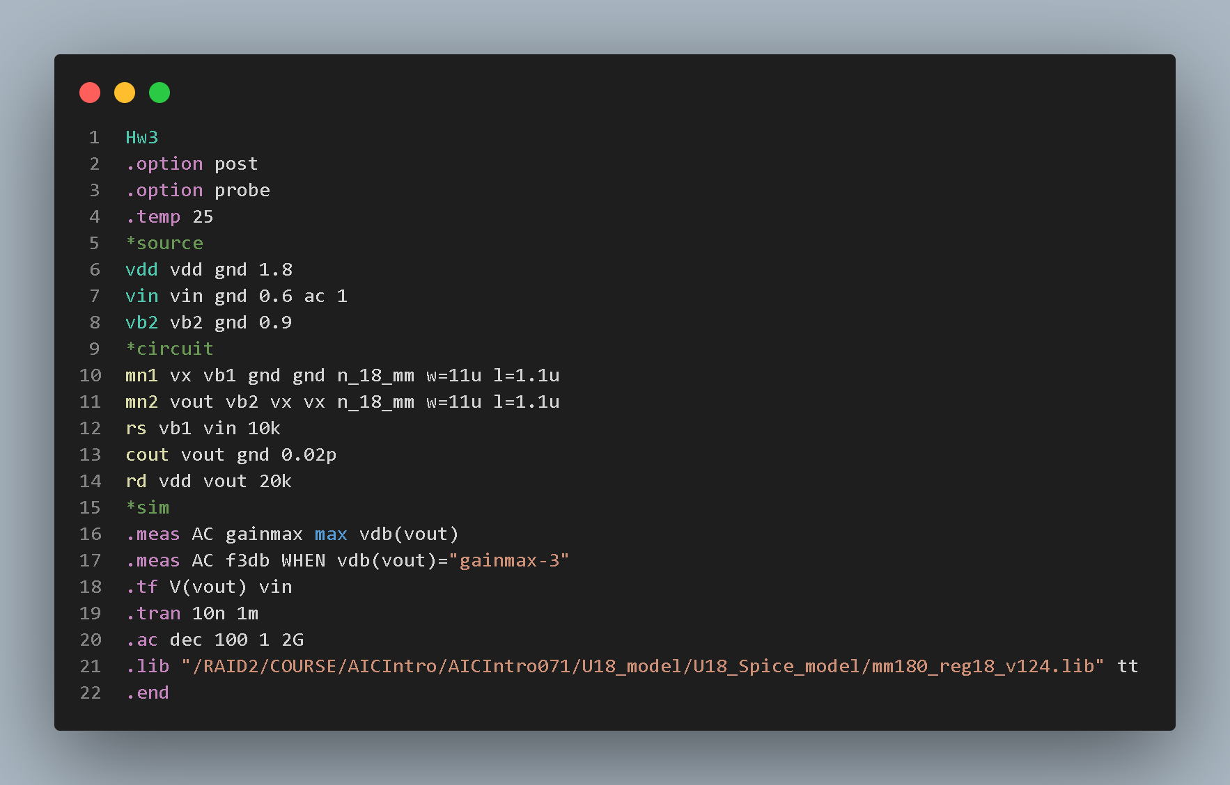

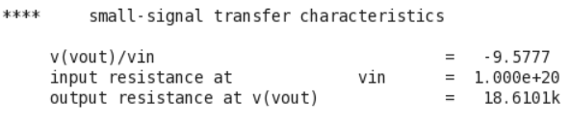

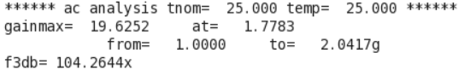

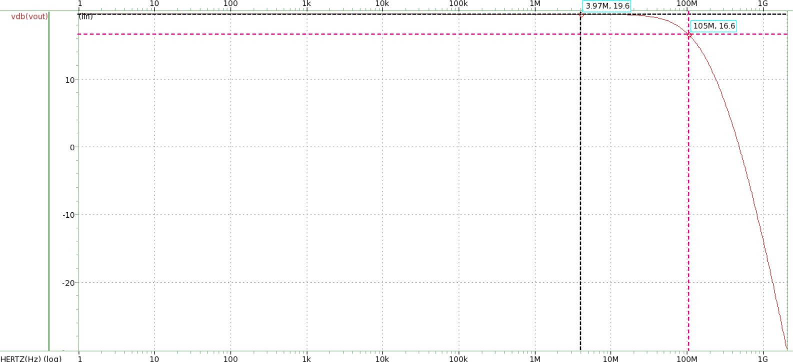

Gain=-9.577

f-3db=105MHz

|  |  |  |  |
| --- | --- | --- | --- |
|  | Figure a | Figure b | Figure c |
| Av gain | -9.2867 | 1.3229 | -9.577 |
| f-3db | 101MHz | 214MHz | 105MHz |

1. Compare both low-frequency voltage gain Av and 3-dB bandwidth between these two amplifiers in Figs. (a) and (b). Please explain the reasons why they are larger or smaller.

|  |  |  |  |
| --- | --- | --- | --- |
|  | Av gain | f-3db | Gm |
| Figure a | -9.2867 | 101MHz | 549u |
| Figure b | 1.3229 | 214MHz | 173u |

**Answer:**

The reason that the Av gain of Figure(a) is smaller than Figure(b) is because the output resistance of both figure(a) and figure(b) is approximately the same. However, the transconductance Gm of figure(a), which is equal to 549uS, is much larger than that of figure(b), which is equal to 173uS. The Av gain formula is -GmRout. Thus, the result shows that the magnitude of gain of figure(a) is larger than figure(b).

How about the f-3db point? Generally, The cutoff frequency can be approximately calculated by using the formula f-3db $=\frac{1}{2π*RC}$. Figure(a) is dominated by the input node, which is equal to 179MHz. The result of the spice and the calculation is both at the 1xxMHz level. This is acceptable. Figure(b) is dominated by the output node. The result is equal to 252MHz, which is close to the spice result. The error between them is because the calculated result is just an approximate way. Figure(a)’s RC multiply is larger than figure(b). Thus, it causes a larger -3db point at figure(b).

1. Compare both output noise voltage and input-referred noise between these two amplifiers in Figs. (a) and (c). Please explain the reasons why they are larger or smaller.

**Figure(a).**

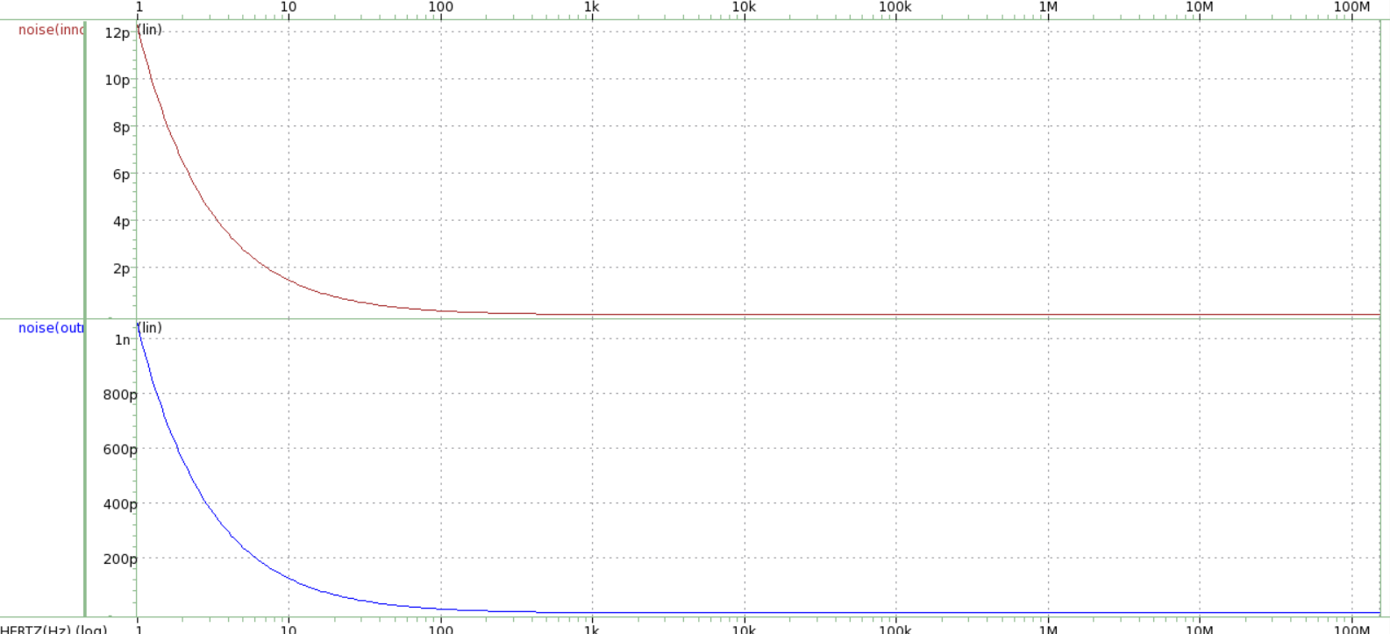

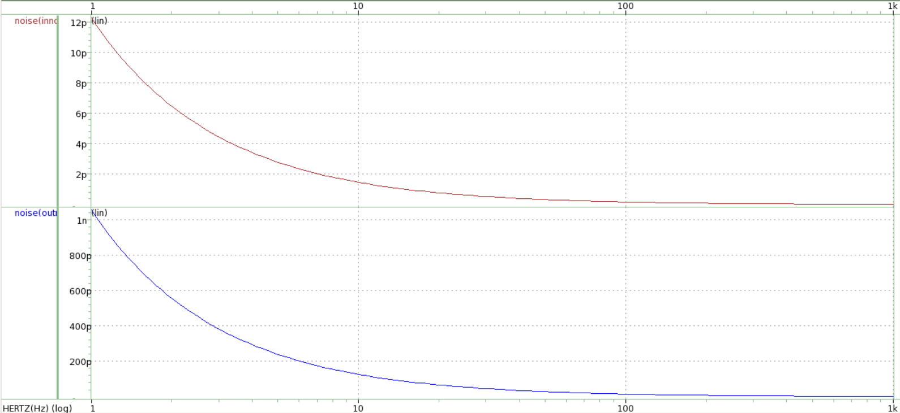

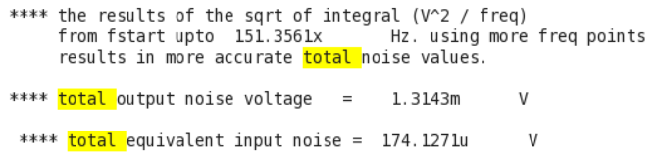

**Figure(c).**

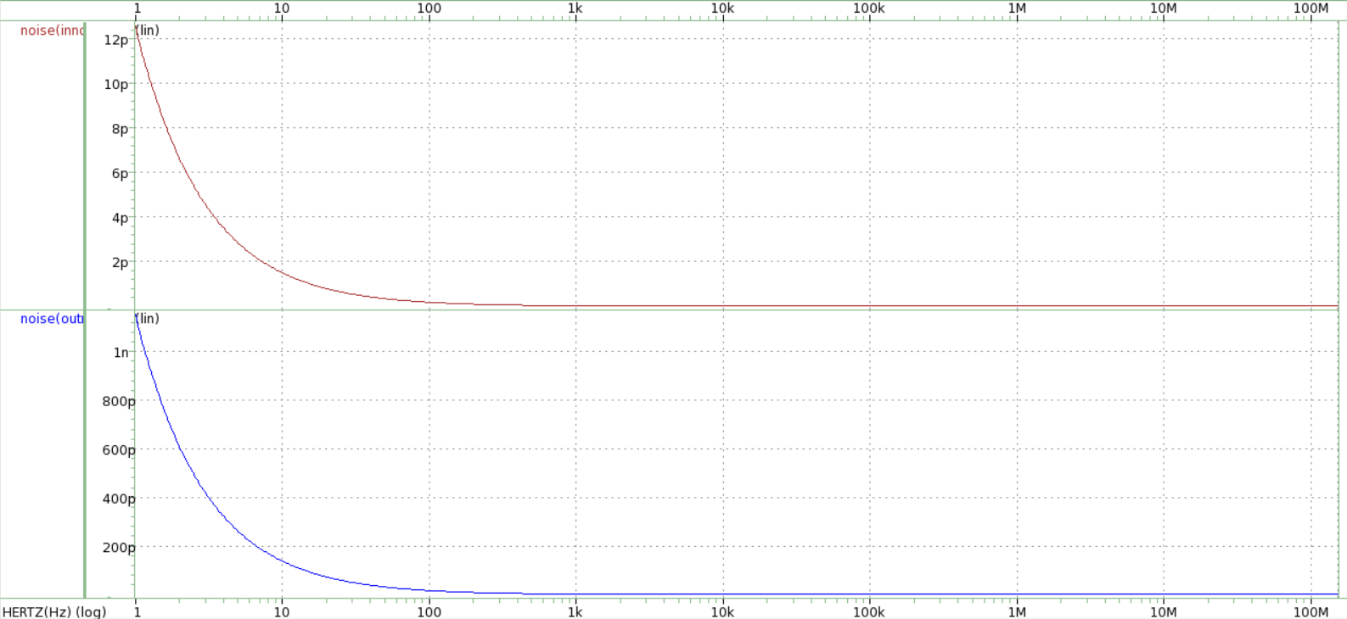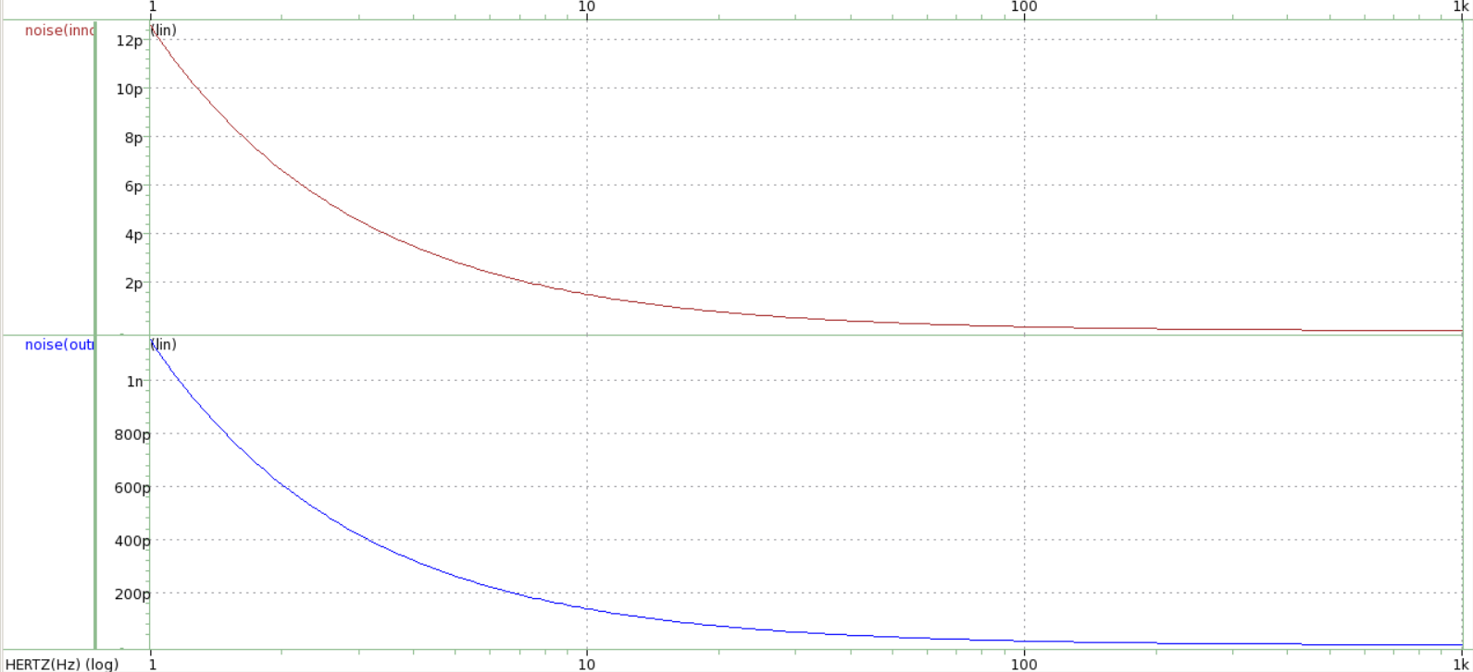

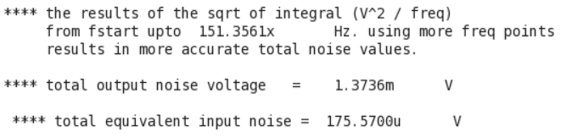

Answer:

From the result above, it is found that both the input and output noise of figure(c) are larger than that of figure(a), but just a little bit of difference between them. One of the main reasons is a larger bandwidth will generally cause a larger noise. From the results in part(a), the bandwidth of figure(a) is 101MHz, which is smaller than 105MHz, the bandwidth of figure(c). Thus, the noise of figure (c) in the output and input are larger than the noise of figure(a). This also explains why we need a filter to have a smaller bandwidth and reduce the noise.



Referenced from the Wikipedia.

The second possible reason is that figure(c) passes through a longer distance to reach the final output. We all know that the wires exist parasitic resistance and inductance. Thus, it may have more noise if the elements of the circuit are more.

1. Please explain why the noise of MN2 contributes negligibly to the total output noise in Fig. (c)

Answer:

First, if it is assumed that there’s a noise signal from the gate of MN2, the output of this noise signal will be very small, which can be neglected. This is because of the cascode circuit. The Gm of MN2 will be much smaller than the Gm of MN1, which is due to a large resistance looking below. Then the noise output of MN2 will also be much smaller than MN1. Thus, we can neglect the noise from MN2.